Warning – Dimming Scroll Bar for the SHMI Display – CGEA1.3

Functional Description

The purpose of the Dimming Scroll Bar is to inform the driver of the dimming level to which the interior lamps are set. The Dimming Scroll Bar correlates the DimmingLvlEvnt_No_Actl signal, the Dimming_Lvl signal, and the Operational_Mode to determine when to display the Dimming Scroll Bar warning and whether to display the daytime dimming level or the nighttime dimming level. The Dimming Scroll Bar warning should only be displayed when there is a button press.

This Specification can be used with SHMI Displays only.

Interfaces

Interface Context Diagram (I/O Block Diagram)
Figure 1 Dimming Scroll Bar Warning Function Context Diagram

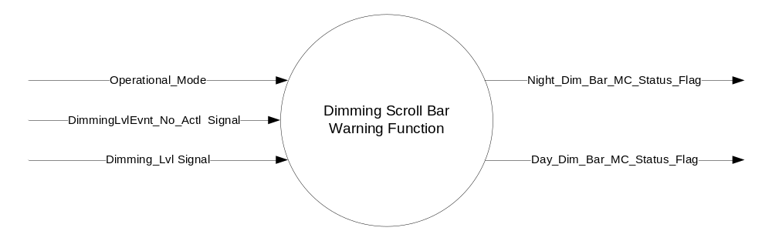

Inputs
      - INTERNAL:

    - Operational_Mode

- MUX messages on the CAN Bus from BCM

- Dimming_Lvl Signal
Signal Name | Size  (bits) | Detail | Units | Res. | Offset | State Encoded | Min. | Max.
Dimming_Lvl | 8 |  | SED | 1 | 0 |  | 0  (0x0) | 253 (0xFD)
 |  | Off |  |  |  | 0x0
 |  | Night_1 |  |  |  | 0x1
 |  | Night_2 |  |  |  | 0x2
 |  | Night_3 |  |  |  | 0x3
 |  | Night_4 |  |  |  | 0x4
 |  | Night_5 |  |  |  | 0x5
 |  | Night_6 |  |  |  | 0x6
 |  | Night_7 |  |  |  | 0x7
 |  | Night_8 |  |  |  | 0x8
 |  | Night_9 |  |  |  | 0x9
 |  | Night_10 |  |  |  | 0xA
 |  | Night_11 |  |  |  | 0xB
 |  | Night_12 |  |  |  | 0xC
 |  | Day_1 |  |  |  | 0xD
 |  | Day_2 |  |  |  | 0xE
 |  | Day_3 |  |  |  | 0xF
 |  | Day_4 |  |  |  | 0x10
 |  | Day_5 |  |  |  | 0x11
 |  | Day_6 |  |  |  | 0x12
 |  | Unknown |  |  |  | 0xFE
 |  | Invalid |  |  |  | 0xFF

- DimmingLvlEvnt_No_Actl Signal
Signal Name | Size  (bits) | Detail | Units | Res. | Offset | State Encoded | Min. | Max.
DimmingLvlEvnt_No_Actl | 2 |  | Unitless | 1 | 0 |  | 0  (0x0) | 3 (0x3)

Output
- Night_Dim_Bar_MC_Status_Flag, which is used to control the state of the Nighttime Dimming Scroll Bar Message
- Day_Dim_Bar_MC_Status_Flag, which is used to control the state of the Daytime Dimming Scroll Bar Message

Function/Performance

Operational Modes

Mode | Differentiating Vehicle Conditions
Sleep Mode | Night_Dim_Bar_MC_Status_Flag = Inactive  Day_Dim_Bar_MC_Status_ Flag = Inactive
Limited Mode | Night_Dim_Bar_MC_Status_Flag = Inactive  Day_Dim_Bar_MC_Status_ Flag = Inactive
Normal Mode | Night_Dim_Bar_MC_Status_Flag = Inactive/Active  Day_Dim_Bar_MC_Status_ Flag = Inactive/Active
Crank Mode | Night_Dim_Bar_MC_Status_Flag = Inactive/Active  Day_Dim_Bar_MC_Status_ Flag = Inactive/Active

The above table references the setting of the Warning flags as per this section. However, the actual warning display operational modes are displayed in the Message Center section of this SPSS.

Voltage Levels

Refer to the Cluster Features Table located in the Operational Modes and Voltage Range Strategies Section of this SPSS.

Human-Machine Interface

Visual

Indicator Graphics / Display Format
Message Center Text Warning Message as defined in section 1.3.5.7 of this document.

For actual symbol definition refer to database # F.01 of the 03-0685 ARL requirement.

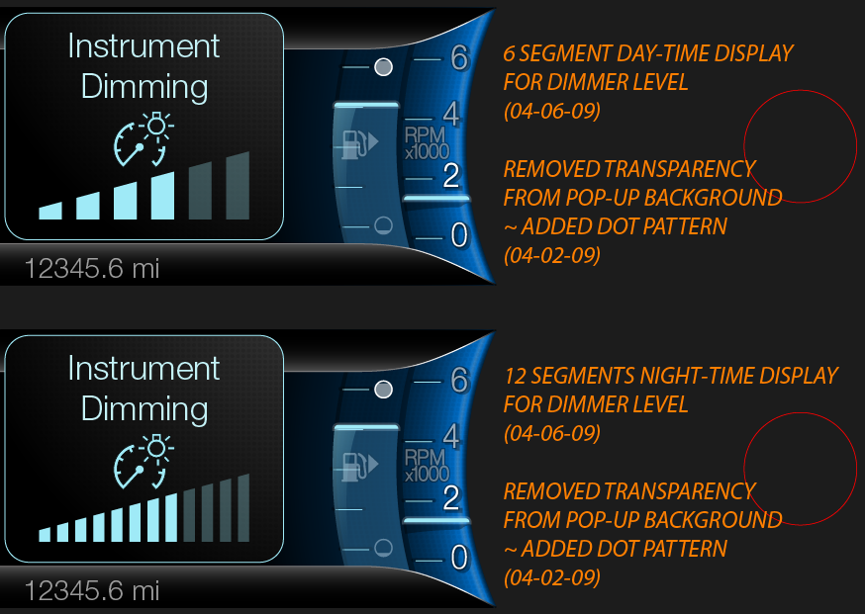

1.3.3.1.2 Indicator Color Coordinates

Reference section COLOR & ILLUMINATION REQUIREMENTS (GRAPHICS).

Audio

None

Switch Control Logic

None.

System Accuracy

Within 100 msec of receiving a message that results in a change of state the cluster will update the output flag to the proper state.

Operation: Performance and Functional Subsystem Algorithm Flowchart / State Diagram

Subsystem Algorithm Flowchart / State Diagram

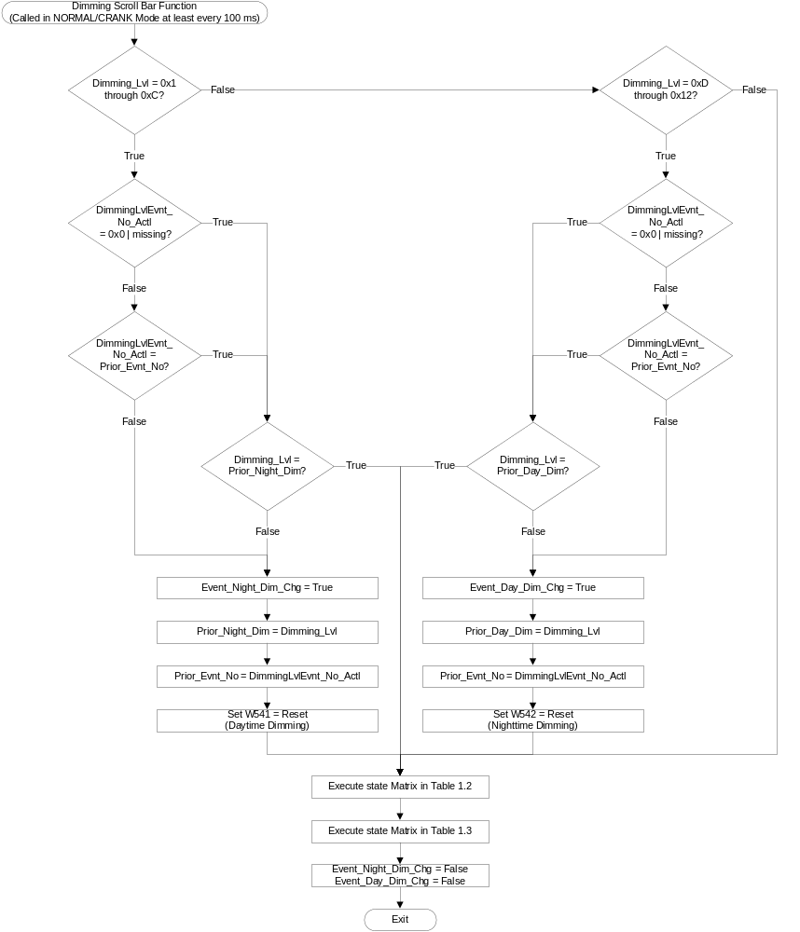
- State Matrix for Night_Dim_Bar_MC_Status_Flag and Day_Dim_Bar_MC_Status_Flag
Operational  Mode | Dimming_Lvl signal | Event_Night  _Dim_Chg | Event_Day  _Dim_Chg | Night_Dim_Bar_  MC_Status_Flag | Day_Dim_Bar_  MC_Status_Flag | NWMD_Timer
Normal  or Crank | 0x1 – 0xC | True | False | Active | Inactive | Reset and Start
Normal  or Crank | 0xD – 0x12 | False | True | Inactive | Active | Reset and Start
Normal | Missing as per 1.4.1 | X | X | Inactive | Inactive | No Change
All other cases |  |  |  | Inactive | Inactive | No Change

Note: The Dimming Bar in the warning should be refreshed every time that the NWMD_Timer is Reset and Started.

- State Matrix for Dimming_Bar_Display
Dimming_Lvl signal* | Dimming_Bar_Display
0x0 | Off
0x1 | 1 Nighttime
0x2 | 2 Nighttime
0x3 | 3 Nighttime
0x4 | 4 Nighttime
0x5 | 5 Nighttime
0x6 | 6 Nighttime
0x7 | 7 Nighttime
0x8 | 8 Nighttime
0x9 | 9 Nighttime
0xA | 10 Nighttime
0xB | 11 Nighttime
0xC | 12 Nighttime
0xD | 1 Daytime
0xE | 2 Daytime
0xF | 3 Daytime
0x10 | 4 Daytime
0x11 | 5 Daytime
0x12 | 6 Daytime

*When Dimming_Lvl signal value is >0x12 or unknown or missing, No state change in Dimming_Bar_Display value

Operation Description (supports algorithm flowchart /state diagram)

- DimmingLvlEvnt_No_Actl is a 2 bit event counter that is incremented at each dim-up and each dim-down button press event only if Dimming_Lvl is not OFF. When Dimming_Lvl = OFF the value will not change. 0x0 is a special value reserved for reset. Any actual event will change the counter to a new non-zero number. The Dimming Scroll bars should only be displayed when there is a button press as indicated by a change in value of DimmingLvlEvnt_No_Actl.
- Night_Dim_Bar_MC_Status_Flag = Active, Warning ID W542 will be Active.
- Day_Dim_Bar_MC_Status_Flag = Active, Warning ID W541 will be Active.
- The Dimming Scroll Bar pop up warning will update whenever Event_Night_Dim_Chg or Event_Day_Dim_Chg is True to indicate the latest dimming level. The pop up warning will be displayed for 4 seconds after the last change of the dimming level.
- If the lighting changes between Day and Night mode, the Dimming Scroll Bar pop up warning will not update unless Event_Night_Dim_Chg or Event_Day_Dim_Chg is True.
- The Dimming Scroll Bar is composed of 12 segments for nighttime and 6 segments for daytime that are displayed according to Dimming_Bar_Display. The left/bottom most segment indicates the lowest lighting level and the right/top most segment indicates the highest lighting level.
- For definition of how the Message Center arbitrates and displays Active warnings, see the Warning / Alert Display Logic Diagram, located in the Message Center – X Display with W Button Interface section of this SPSS (where X and W are appropriate values in this document).

Function Safety Classification (EMC)

Class B

Memory Storage
Parameter Name | Description | Value at  Battery Connect | Value at  Module Wake-up
Day_Dim_Bar_MC_Status_Flag | State variable used by M/C Warning Arbitrator | Inactive | Inactive
Dimming_Bar_Display | Number of Dimming Scroll Bar segments to be displayed in the MC display | 0 (0x0) | 0 (0x0)
Dimming_Lvl Signal | CAN Signal sent from the BCM | Off (0x0) | Do Not Init
DimmingLvlEvnt_No_Actl Signal | CAN Signal sent from the BCM | (0x0) | Do Not Init
Event_Day_Dim_Chg | Used to indicate “Change” Event | False | False
Event_Night_Dim_Chg | Used to indicate “Change” Event | False | False
Night_Dim_Bar_MC_Status_Flag | State variable used by M/C Warning Arbitrator | Inactive | Inactive
Operational_Mode | 4 state indicator for cluster operational mode | Limited | Limited or Normal  or Crank
Prior_Day_Dim | Daytime Dimming Level used to determine if latest received value is changed | Off (0x0) | Do Not Init
Prior_Night_Dim | Nighttime Dimming Level used to determine if latest received value is changed | Off (0x0) | Do Not Init
Prior_Evnt_No | Dimming Level Event Number from the previous software loop. | 0x0 | Do Not Init

Prove Out

No.

Reconfigurable Telltale

No.

Message Center Msg

Warning message ID W541 and W542 as defined in the Text Message List section of this SPSS.

Error Handling

Missing Message Strategy

The signals will be declared missing as per the Diagnostics section of this SPSS.

DTCs states and history will be determined as per the Diagnostics section of this SPSS.

Diagnostics

Self Test

None

Engineering Test Mode

Not Applicable

Part II Performance

Supported Diagnostic Trouble Codes (DTCs)
DTC | Description | Condition
C14000 | Lost Communication with Body Control Module (BCM) | Dimming_Lvl Signal OR DimmingLvlEvnt_No_Actl Signal is missing

Reference Specification

IS-0001 WARNINGS/INDICATORS/DISPLAYS PROVEOUT
IS-0052 OPERATING VOLTAGES - FUNCTIONAL/PERFORMANCE
IS-0069 FUNCTIONAL IMPORTANCE CLASS
IS-0324 WINDSHIELD & OTHER REFLECTIONS
IS-0327 WARNING INDICATOR EVALUATION
IS-0379 NORTH AMERICAN WARNINGS AND INDICATORS STRATEGY

IL-0017 TELLTALE AND INTERIOR ILLUMINATION – COLOR AND INTENSITY
IL-0019 GENERAL ILLUMINATION DIMMING
IL-0021 CRAFTSMANSHIP – DISPLAYS
IL-0022 GENERAL ILLUMINTATION COLOR
IL-0023 CLARITY/LEGIBILITY/READABILITY/VISUAL CONTRAST
IL -0043 OPERATIONAL ENVIRONMENT FUNCTIONALITY
IL -0045 COLOR
IL -0047 TELLTALE, INDICATOR AND DISPLAY LIGHT INTENSITY
IL -0048 ILLUMINATION ACCEPTABILITY

03-0661 PLACEMENT: CONTROL AND DISPLAY LOCATIONS
03-0662 PLACEMENT: LOGICAL GROUPING FUNCTION AND USAGE
03-0664 PLACEMENT: DOWN VISION TO COMPONENTS WITH HIGH VISUAL DEMAND
03-0665 PLACEMENT: EXPECTED LOCATIONS OF CONTROLS AND DISPLAYS VDS
03-0670 INTERIOR VISIBILITY
03-0671 INTERIOR VISIBILITY: REFLECTIONS FROM COMPONENTS & SURFACES
03-0672 INTERIOR VISIBILITY: REFLECTIONS IN DISPLAYS
03-0673 INTERIOR VISIBILITY: VISUAL OBSCURATIONS
03-0674 INTERIOR VISIBILITY: ILLUMINATION CONTROLS / DISPLAYS
03-0675 INTERIOR VISIBILITY: VEILING GLARE
03-0677 INTERIOR VISIBILITY: SUNLIGHT WASHOUT
03-0681 IDENTIFICATION: CHARACTER AND SYMBOL SIZE
03-0682 IDENTIFICATION: LEGIBILITY
03-0685 IDENTIFICATION: SYMBOLS, ABBREV FOR CONTROL
03-0721 LOGIC OF OPERATION: OPERATIONAL STEREOTYPES
03-0722 LOGIC OF OPERATION: INTERPRETATION
03-0723 LOGIC OF OPERATION: USE OF SYSTEMS WITH VISUAL DISPLAYS

Revision History
SPSS Module Revision History

Revision  Level | Name | Change Description | Date
1.0 | V. Patel | Updated for CGEA 1.3 based on CGEA STSS v1.1  Section 1.2.2 – Removed table referencing the HS-CAN message that contains the input signals.  Section 1.4 – Rewritten. Deleted references of specific missing message flags and timer.  Section 1.5.3 – Deleted DTC logging criteria from the table. | 4/13/2010
2.0 | J. Gregoire | The Dimming Scroll bars should only be displayed when there is a button press. This update adds logic to support this restriction. BCM signal should support S550, P552, CD4.2, and later programs.  Section 1.1 – Added DimmingLvlEvnt_No_Actl Signal  Figure 1 – Added DimmingLvlEvnt_No_Actl Signal  Table 1.1 – Added for DimmingLvlEvnt_No_Actl Signal  Section 1.3.5 – Added logic for DimmingLvlEvnt_No_Actl to flowchart. Added Execute state Matrix in Table 1.2 to flowchart. Updated Table 1.2 to Table 1.3 in flowchart.  Section 1.3.5.1 – Added bullet point on DimmingLvlEvnt_No_Actl. Updated bullet point on stating the waring will stay up for 4 seconds after the last button press.  1.3.5.3 – Added Prior_Evnt_No. | 4/2/2013
2.1 | J. Gregoire | Delete reference to Dome_Lamp_MC_Status_Flag  Section 1.3.5.1 – Delete “The Dimming Scroll Bar pop up warning will also display when Dome_Lamp_MC_Status_Flag is Active.” From forth bullet point. | 9/17/2013
2.2 | J. Gregoire | Issue discovered by Visteon. If Daytime Scroll Bar warning (W541) is Active and Displayed and TA_Timer is not Expired when Event_Night_Dim_Chg becomes True, the Nighttime Scroll Bar warning (W542) will be displays then the W541 will be displayed again until the TA timer is expired. The same is true when Nighttime dimming changes to Daytime dimming in a similar scenario.  Section 1.3.5, Dimming Scroll Bar Function flowchart – Add “Set W541 = Reset (Daytime Dimming)” and “Set W542 = Reset (Nighttime Dimming)” | 9/18/2013
2.3 | S. Watkins  M. Hakim | Also corrected section numbering, Added DimmingLvlEvnt_No_Actl Signal to the Memory Storage table, corrected value at module wakeup for Dimming_Lvl Signal form 0x0 to “Do Not Init” ,and updated the document footer. | 9/24/2013
2.4 | S. Watkins  M. Hakim | This update is to account for logic when CAN signal is missing or invalid, and also add the Invalid DTC with its condition. Changes as follows:  - Added “| missing” to the first decision diamond in the flowchart logic, Section 1.3.5.1  - Added note regarding Dimming_Lvl signal value for Table 1.3, Section 1.3.5.1 | 9/30/2013
2.5 | J. Gregoire | Address system compatibility issue to avoid seeing Dimming Scroll Bar warning at every CAN wake up. Change highlighted in Green.  Section 1.3.5.4 – Corrected value at module wakeup for DimmingLvlEvnt_No_Actl Signal and Prior_Evnt_No from 0x0 to “Do Not Init” | 6/16/2014
2.6 | J. Gregoire | The dimming level can change multiple levels if the dimming button is pressed and held. The dimming scroll bar only indicates the initial dimming level when the button is pressed. The dimming scroll bar should display each dimming level change resulting from a button press. Change highlighted in Blue.  Section 1.3.5.1 – Update Dimming Scroll Bar Function flowchart.  Table 1.2 – Add NWMD_Timer column and Note below the table.  Section 1.3.5.2 – Update bullet point regarding how long the pop up will be displayed. | 10/02/2014

